GIT/HEROKU GUIDE

Table of Contents
The Heroku Toolbelt
Git for Windows
Installing SQLite
Grabbing Remote Github Files
Creating/Editing Your Database
Converting your Database to SQL
Uploading to Heroku

This guide is designed be used by people with little to no experience with git or Heroku (or programming really). It can be used to create a new app or to maintain an existing one. Specifically, it deals with the documentation for my database search engine, which can be found here:
https://github.com/veggielover77/searchEngine
Many of the commands here can be easily applied to other projects, and this guide has collected several commands which I had to search to find.

For now, this guide deals exclusively with Windows, but once you have the respective tools installed, the bash commands are the same.

What you will need:
- The Heroku Toolbelt
- Git for Windows
- SQLite3
- The App You Want to Upload

Before we start installing or working on anything, we want to first have at least a folder/directory for the project that we are working on.

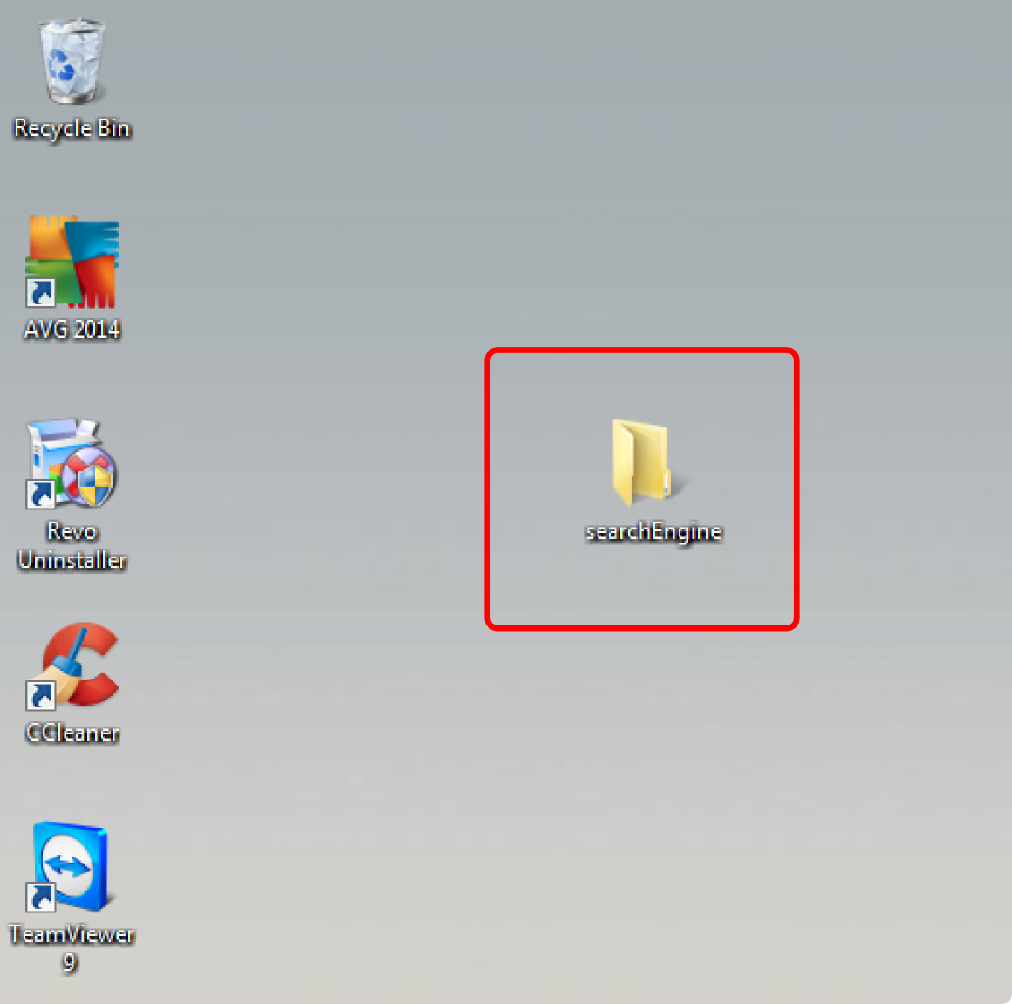
If you do not already have the project files on your computer, then you'll want to create a folder to contain them. For example, I'm creating a folder called 'searchEngine' on my desktop.

Now that we've taken the first step, let's start installing the tools that we will need to build our project.

THE HEROKU TOOLBELT

If you are not a Windows developer, then you have probably rarely used or even seen a terminal in Windows. You might have experience with PuTTY or Cygwin, both tools which allow you to use a Linux terminal on Windows, but we won't be using them here. I found it much easier to use the following tools, but you can adapt the following steps to your needs.

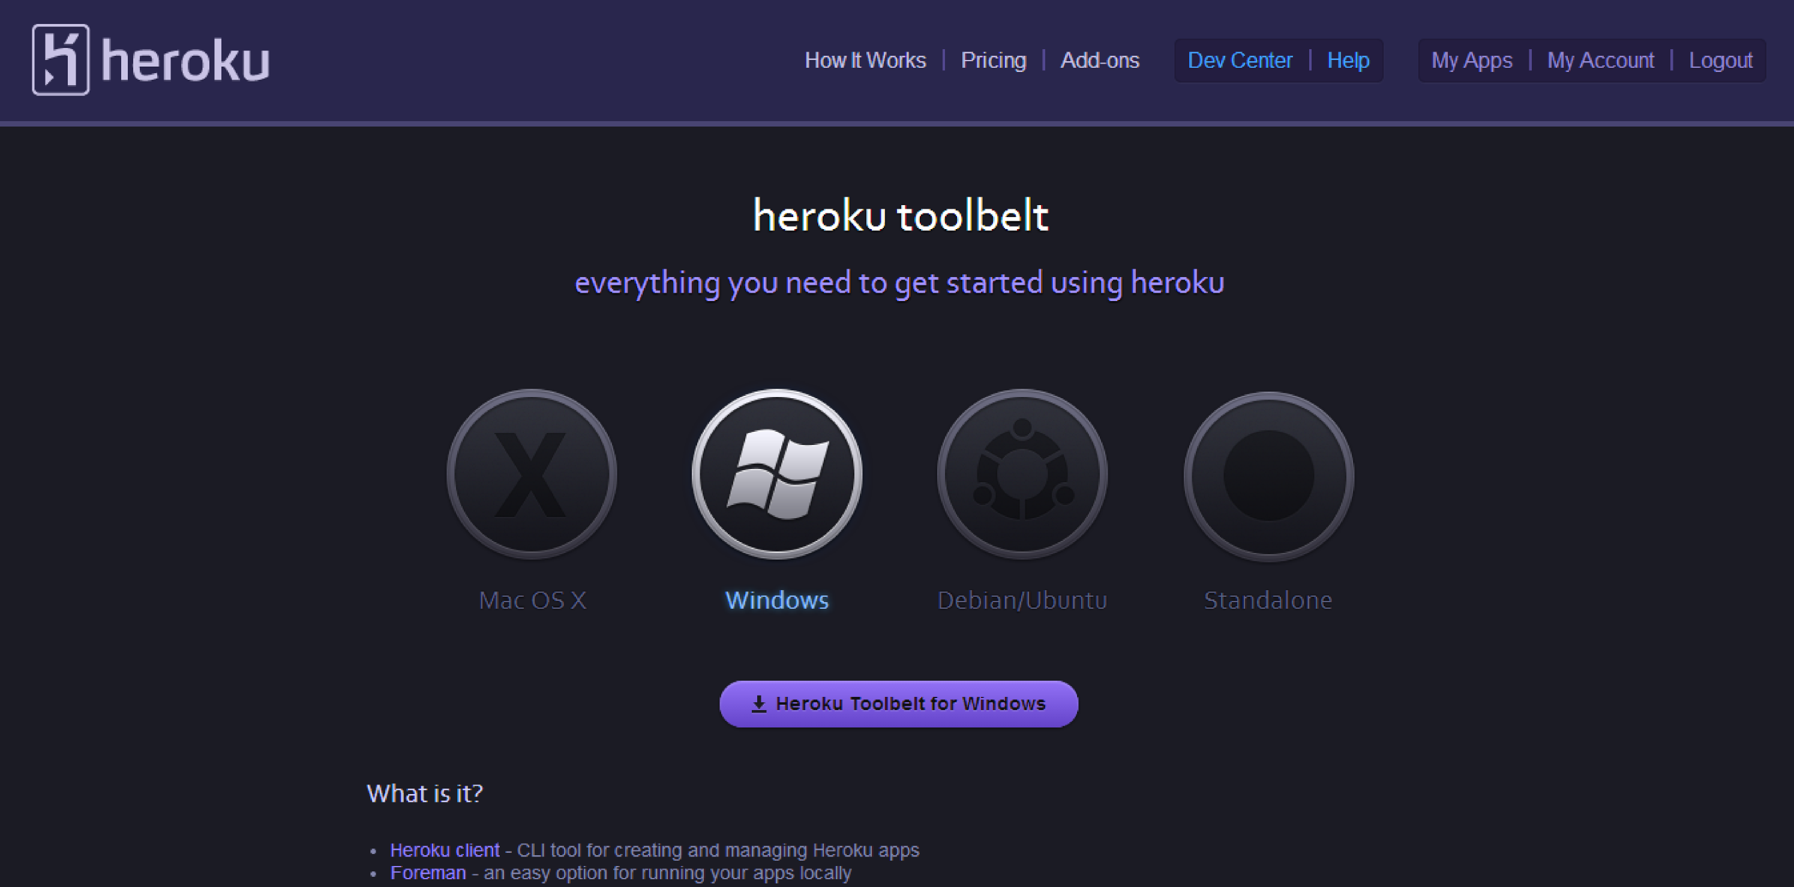
To start, we will need to install the Heroku Toolbelt for Windows. Currently the homepage looks like this:

Make sure you have selected the version for Windows, then go ahead and download it.
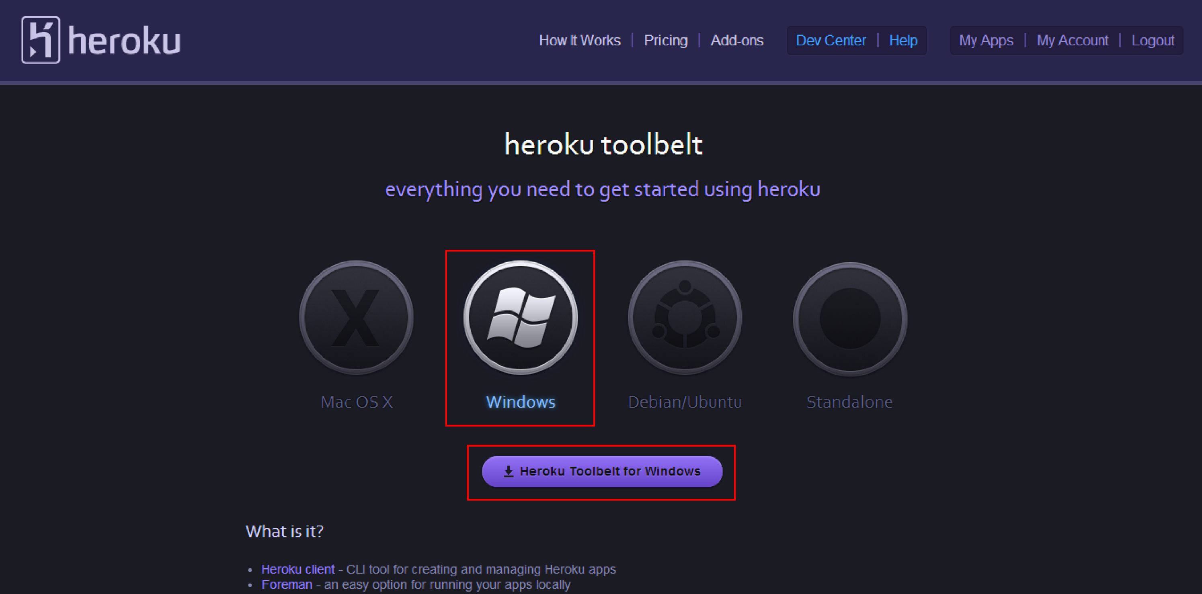

Open and run the downloaded executable, giving it permission to make changes your computer if it asks.

This will take you to the following screen.
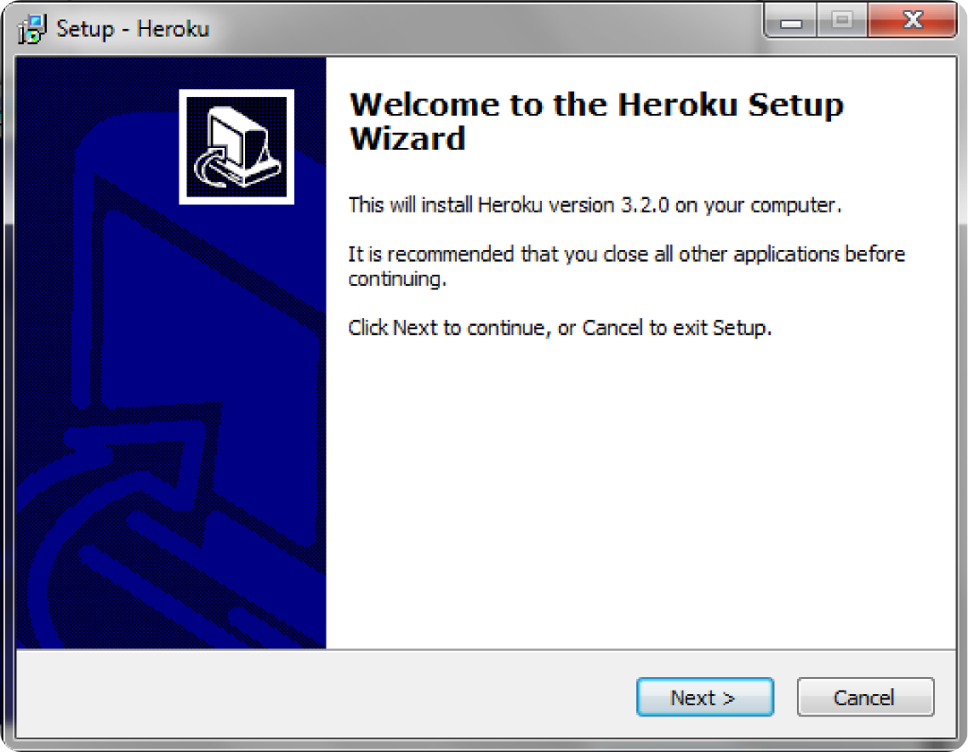

Go ahead and hit 'Next'.
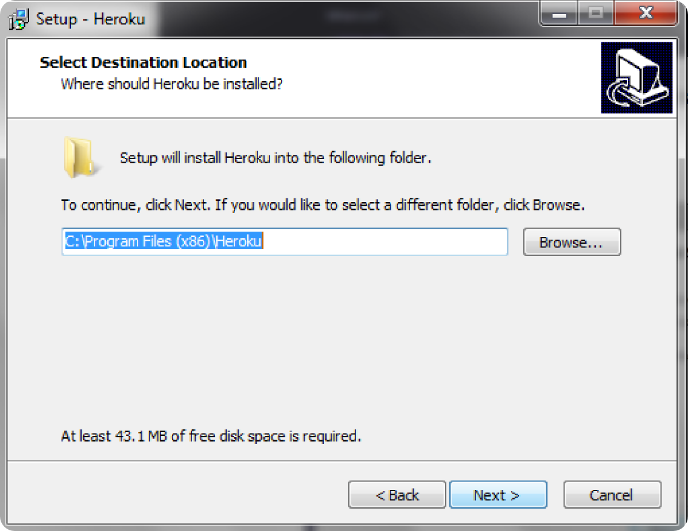

Go ahead and hit 'Next'; the (x86) lets you know that this program is a 32-bit program.

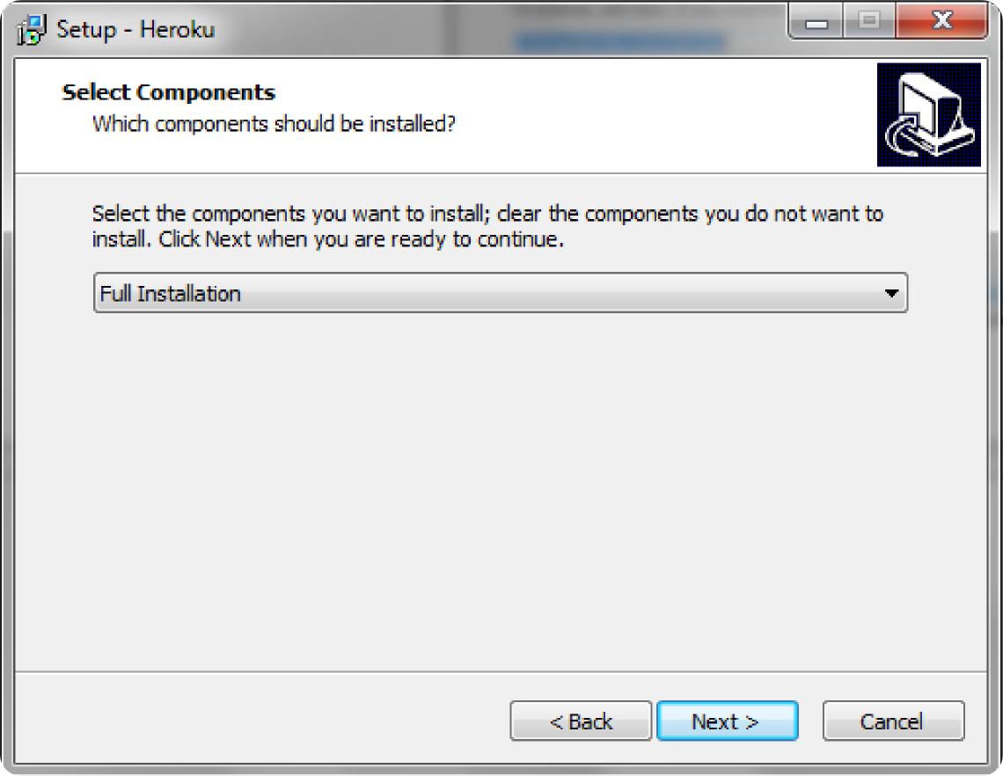

Do the full installation. It's easier than the custom installation, unless you know what you're doing.
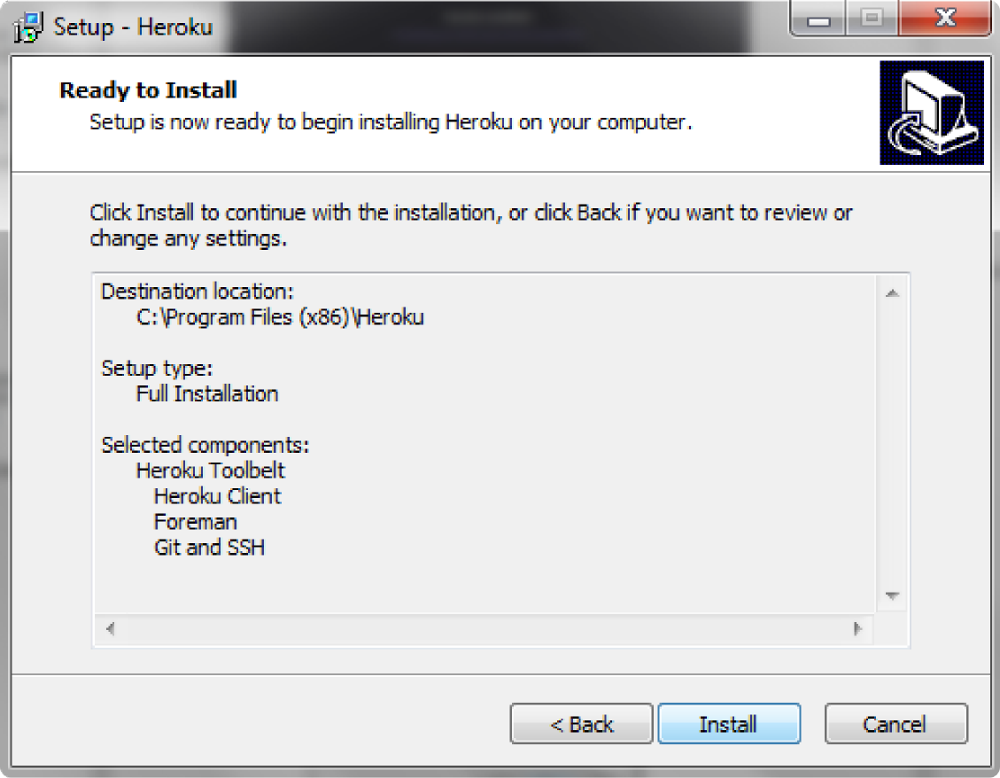

Hit 'Install', and it will install the entire Heroku Toolbelt: the Heroku Client, Foreman, and Git and SSH.
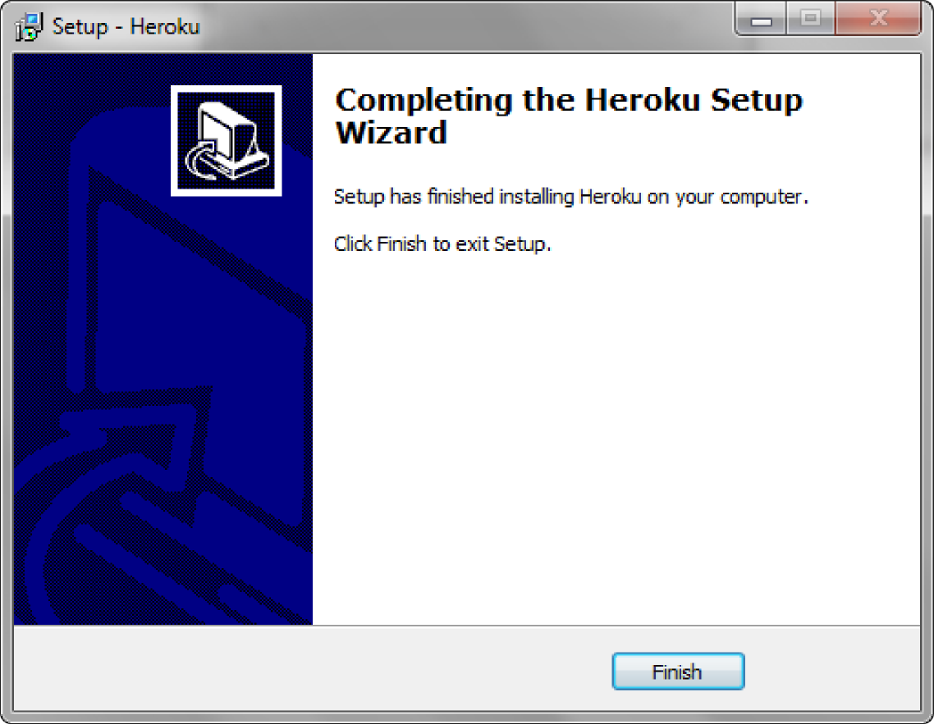

Hit 'Finish' and you're done! You've installed the Herkoku Toolbelt!

GIT FOR WINDOWS

Now that you've installed the tools to connect with Heroku, you'll need to install Git for Windows.
The homepage currently looks like this:
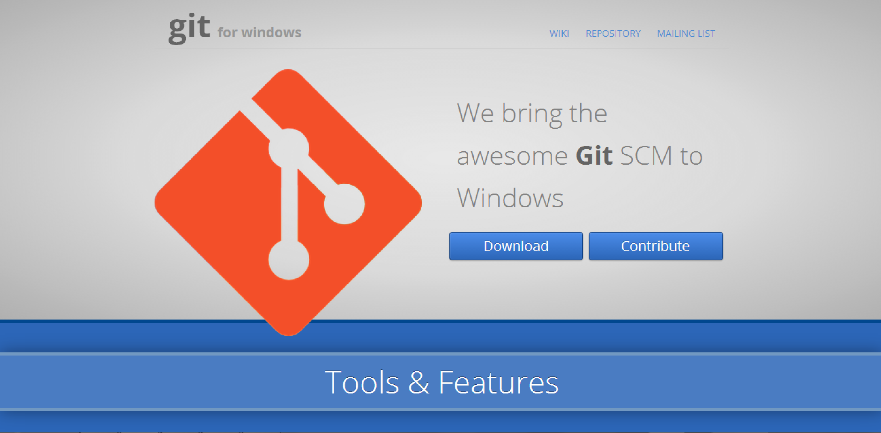

You are welcome to poke around the website a bit and see Git for Windows is all about, but all you have to do if click on 'Download' to move on. Protip: If you mouse over the orange icon, it changes color to look like the Windows logo.
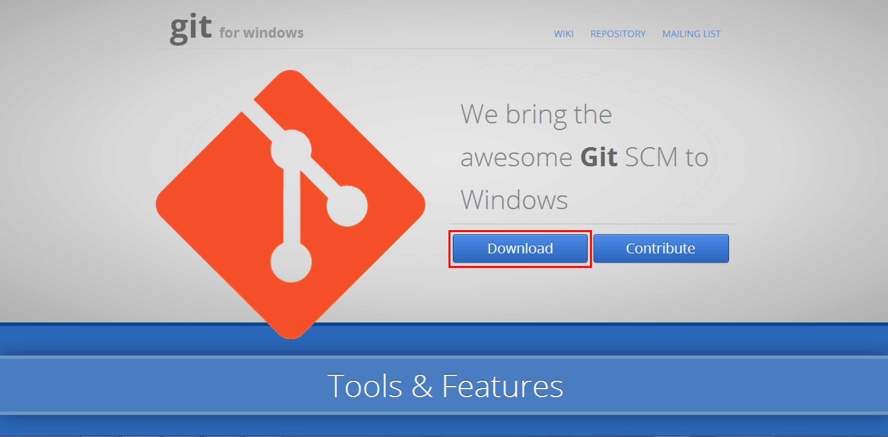

So, run the downloaded executable, giving it permission to run if you have those security features built in. This is what the executable looks like for me:
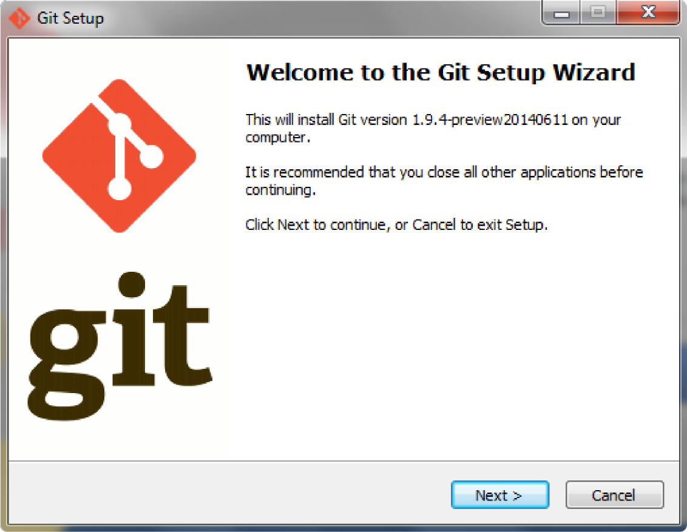

Hit 'Next' to get started.
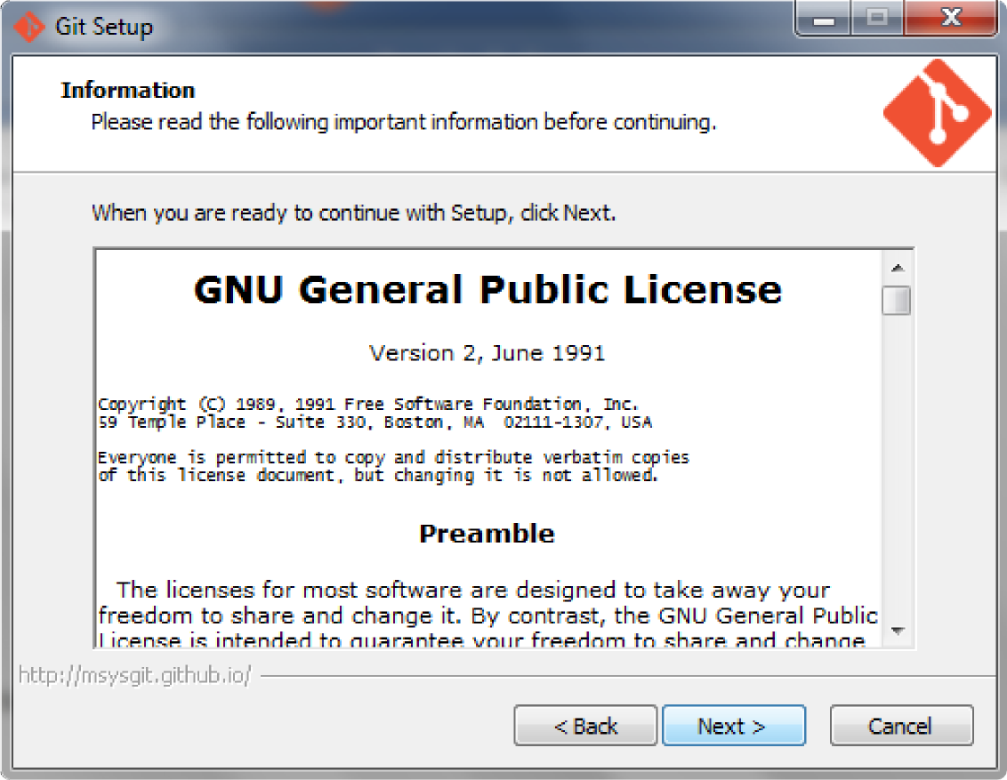

This screen is just telling us about the license. You can read it if you want; mostly it talks about the fact that this is free software. The definition for this has been taken from https://www.gnu.org/philosophy/free-sw.html:

“Free software” means software that respects users' freedom and community. Roughly, it means that the users have the freedom to run, copy, distribute, study, change and improve the software. Thus, “free software” is a matter of liberty, not price. To understand the concept, you should think of “free” as in “free speech,” not as in “free beer”.

The rest of the license mostly goes through talking about when you can share/edit it and redistribution laws and the like. Also it's copyrighted so don't put your own name on it.

Anyway, hit 'Next' to move on.
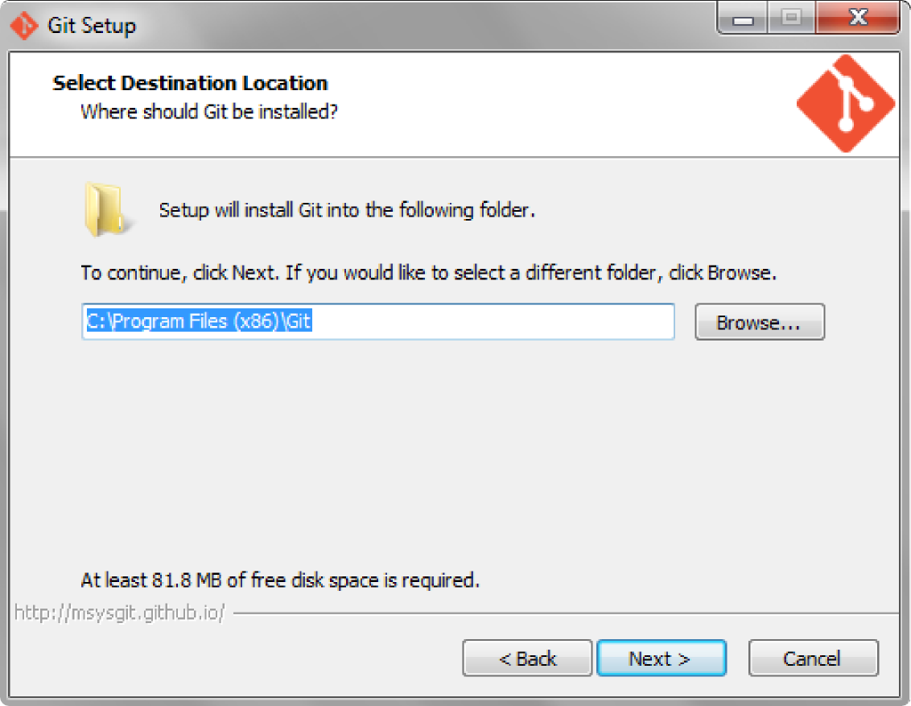

Again it just tells us it's installing the files under 'Program Files (x86)'. They're stored here—out of the way—so you don't change them on accident. Hit 'Next' to move on.

In this window, make sure you select 'Simple context menu'; this will include 'Git Bash Here' and 'Git GUI Here'. 'Git Bash Here' is the bash window that we will be using to execute our commands. GUI (pronounced gooey) means graphical user interface, and will allow you to go through the same commands using a window like the installation window. This guide specifically uses the bash command line.

As far as everything else, I don't like having extra icons on my desktop or start menu, I don't care about a TrueType font, and we want to two 'Associate...' options. If you want, you can add icons or mess with the font, then hit 'Next'.
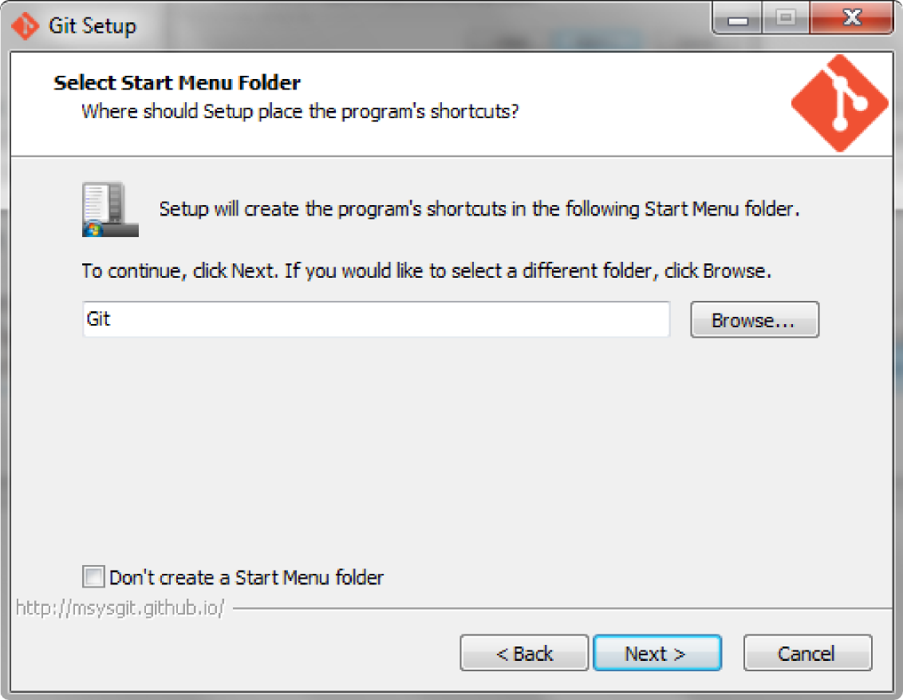

If you don't want to create a Start Menu folder, then make sure to click that box. Hit 'Next'.
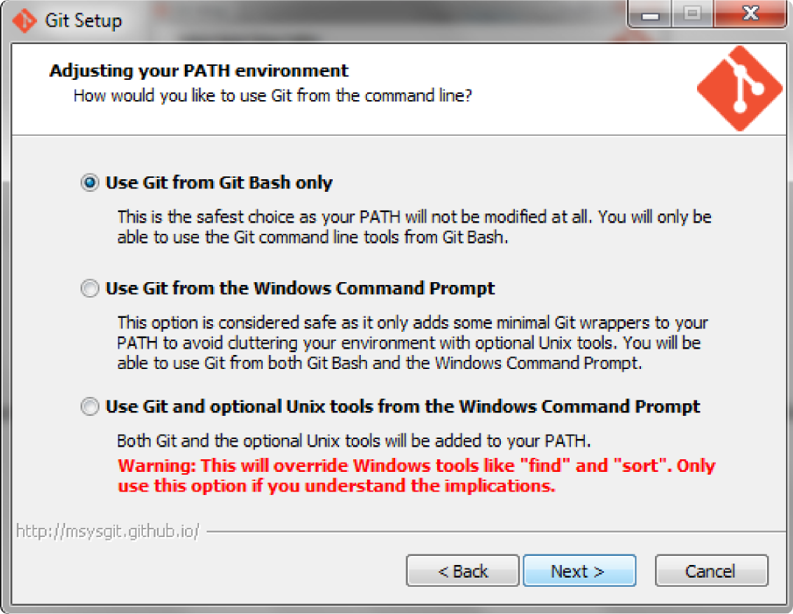

I like the 'Use Git from Git Bash only' option. I don't use the Windows Command Prompt if I can help it, because a lot of the Windows commands are different than the Linux ones. I'm not a Windows developer, and assuming that you aren't either, the first option is really all you need. Hit 'Next'.
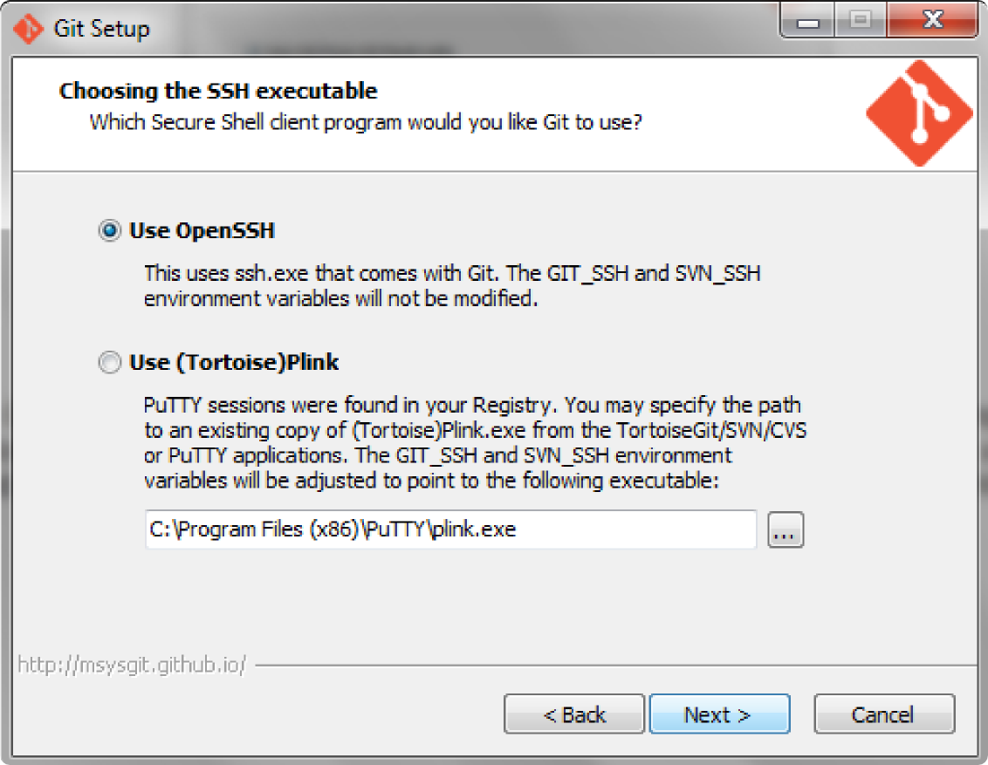

I use PuTTY, so I think my window will look different than yours if you don't. However 'Use OpenSSH'— which looks like the default option—is the easiest choice. Make sure it is selected and hit 'Next'.

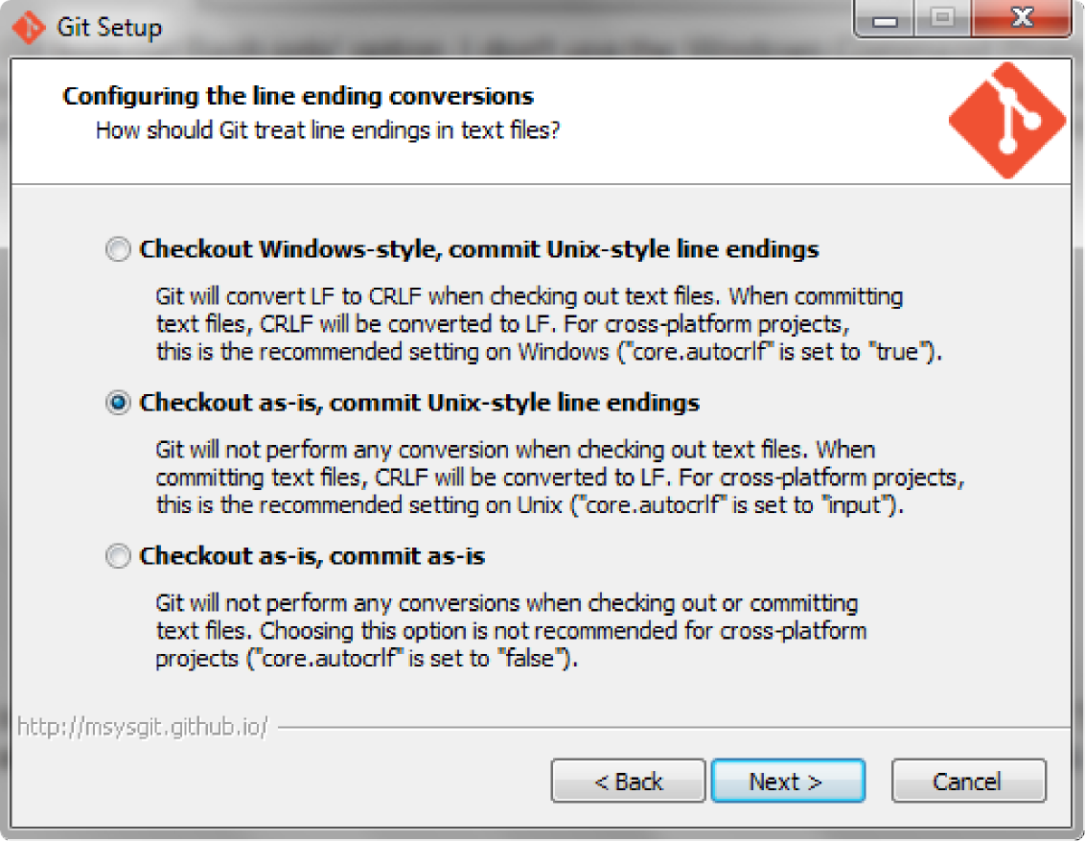

Windows and Unix operating systems encode line breaks differently; Windows uses CRLF (carriage return, line feed) and Unix uses LF (line feed). Since all of the files for the search engine were originally written in Linux we don't want any conversions happening, especially since we will be constructing/editing the database with Git Bash. Select the second option, then hit 'Next'.

Now we're installing Git for Windows! Let it run through the installation process. When it is finished, it will display this window:
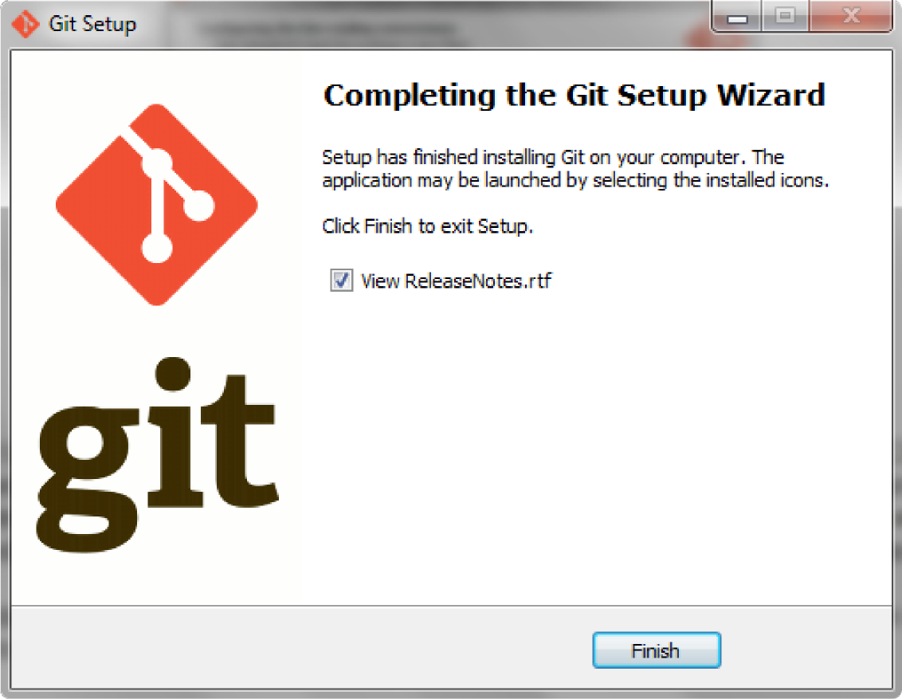

You can look at the release notes if you want, I peeked at them my first time installing, but it's not necessary. Make sure you uncheck that box if you don't want the file to open.

Hit 'Finish' and you're done! You've installed Git for Windows! You'll notice that in the Start Menu there should now appear a folder for 'Git' under 'All Programs'. If you expand 'Git', you should see 'Git Bash' and 'Git GUI'. Git Bash will be the tool we will be using for the rest of this tutorial.

INSTALLING SQLITE3

In order to compile the changes that you make to the database, you are going to also need SQLite3.
Open the link, scroll down to Precompiled Binaries for Windows, and download the file sqlite-shell-win32-*.zip. The * here is used in bash commands to mean anything, so your file name will differ from this, but it should start with sqlite-shell-win32 and end with .zip.

Unzip the file you just downloaded into your project folder (mine is searchEngine on my desktop). Now your project folder should contain sqlite.exe. This means that only from this folder we can run SQLite3 commands, if you want to be able to run them from different folders, just put copies of the executable into whichever folders you want.

GRABBING REMOTE GITHUB FILES

I'm assuming that you are working with the database search engine app that I wrote. If you have your own app all ready to go, then just jump down to “Uploading to Heroku”; the same commands we will use for uploading you can use as well. Most (if not all) of them should transfer over from Windows to Linux.

In either case open Git for Windows or another Bash consol to move on.
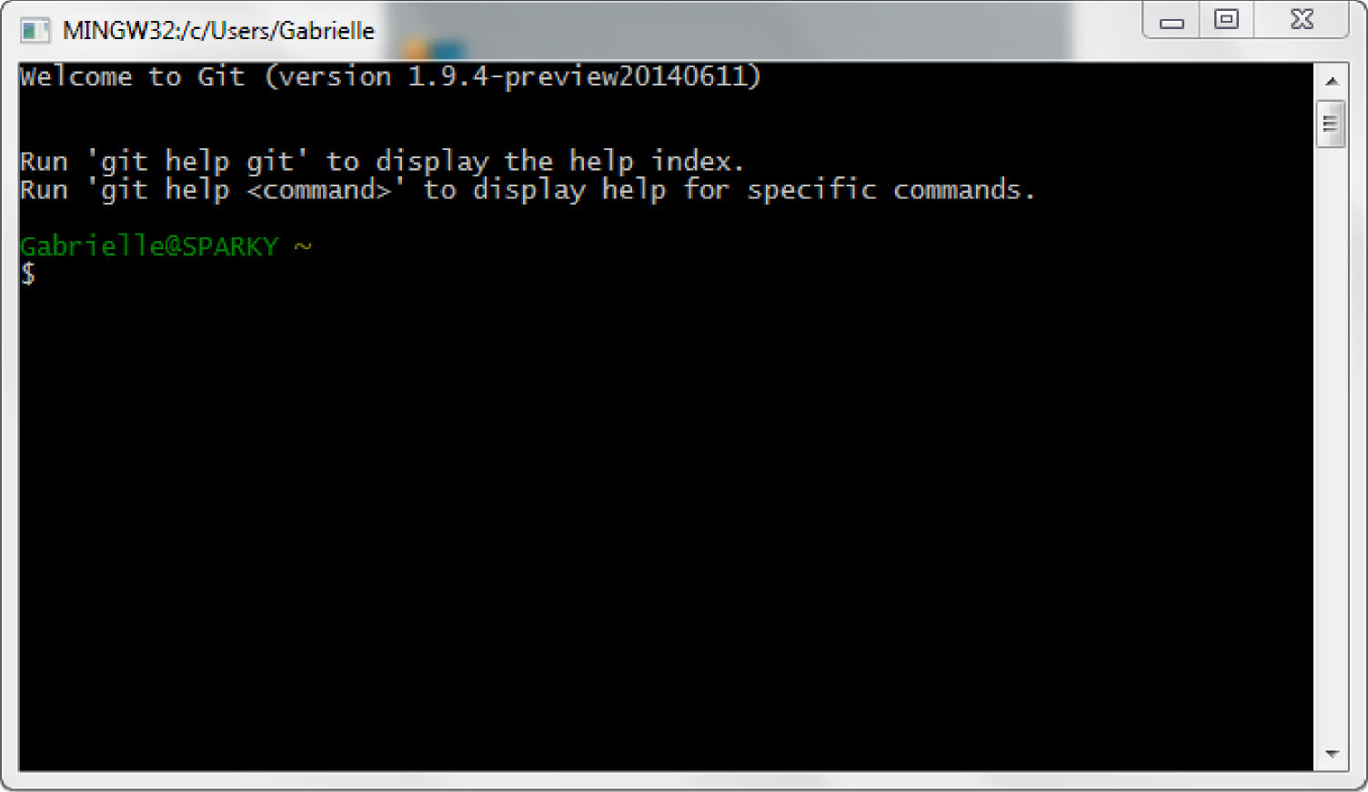

Then, in Git Bash, which should look something like the above when first opened, we are going to move into the folder (directory) that we have created.

Through the rest of this tutorial, anytime there is code that you should type into the consol, it will look like this:
hello world sample code

Right now, we are positioned at home, which is to say that we are currently sitting in your user home folder. Thinking of it in terms of Windows Explorer, my home position looks like this:
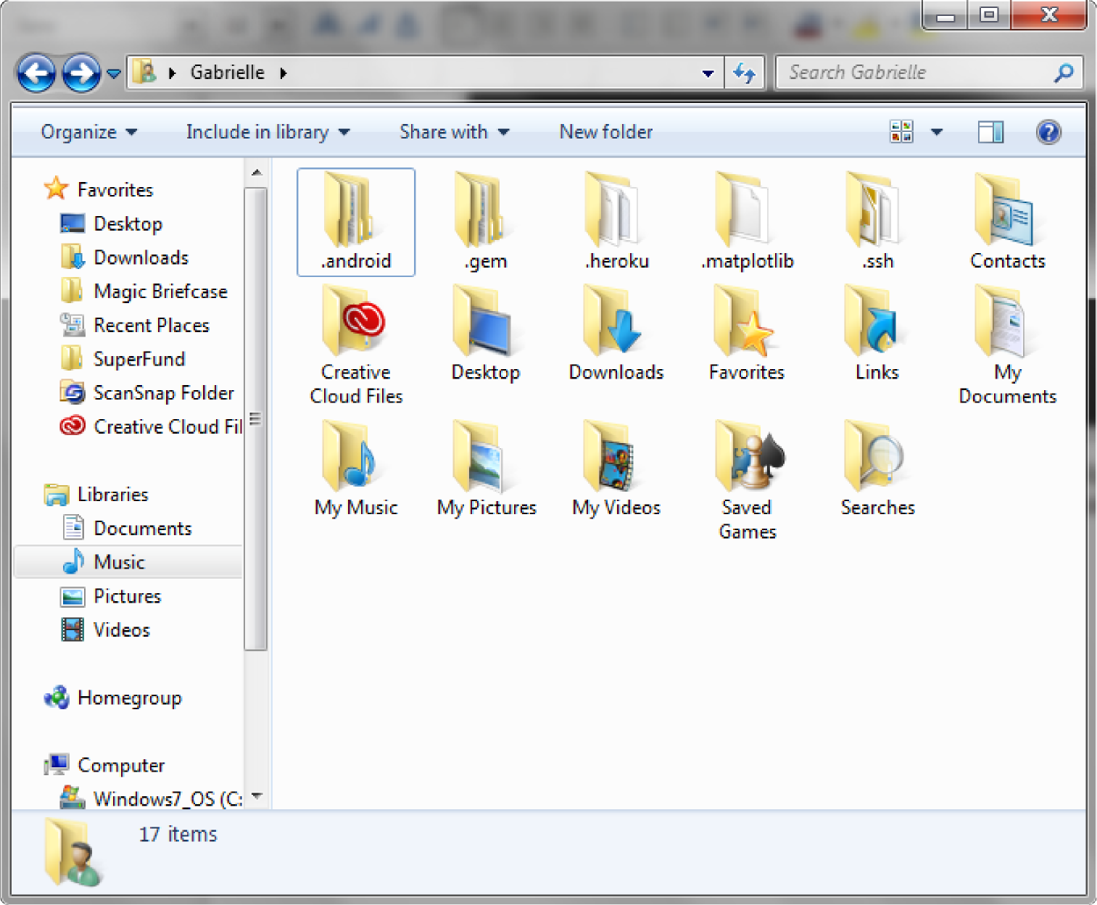

to test your location, you can type
ls
into the terminal.
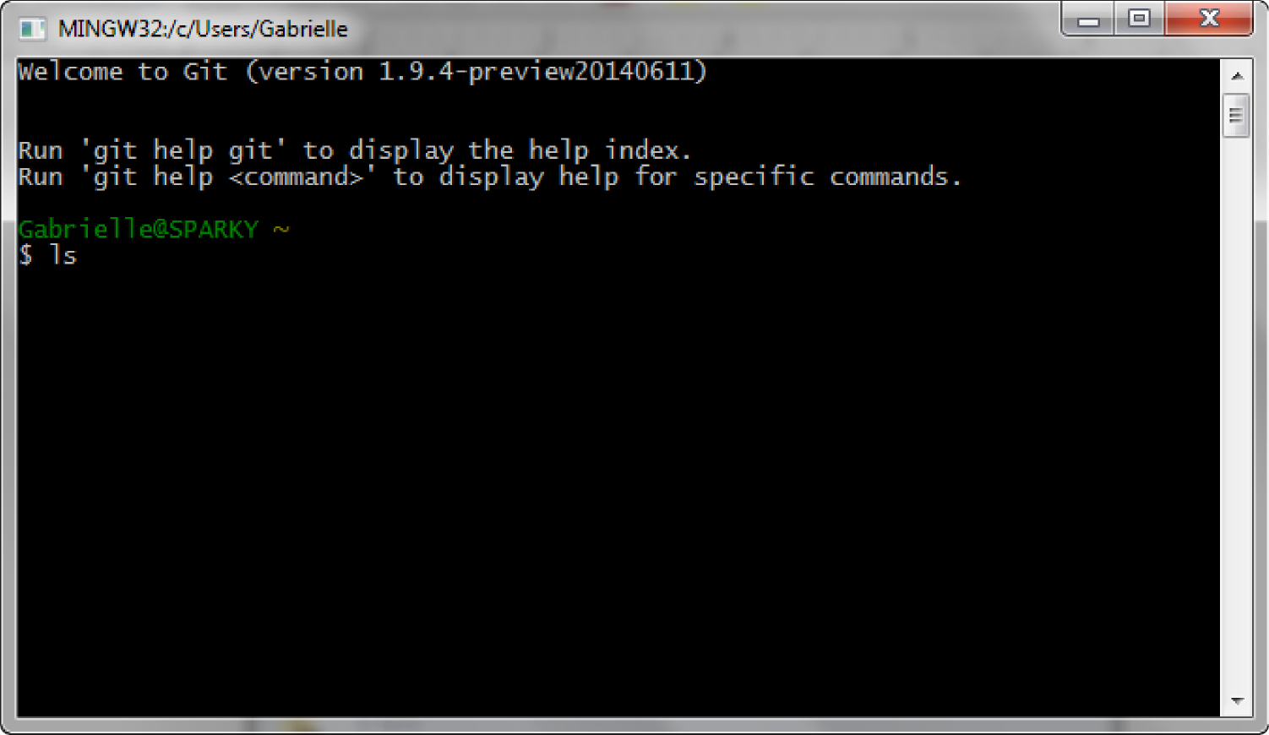

If you hit enter, you should get a list of files and directories (folders). Most of these should match up to your home folder. For me, I got a bunch of extra hidden files.

ls is the command for 'list'. When you execute it, you are asking the terminal to list all of the files in the current directory. Now you will want to change directory (or cd) into the folder where you want to store the project; this should be where you just created a folder. By default it won't color files differently than directories, but if you type
alias ls='ls –-color=auto -aX'
then it will every time you type ls. (-aX tells it to list all files (incl. hidden ones) in alphabetical order). However, when you restart Git Bash, you'll have to retype that command. Files should still be white, but directories will show as blue, and other file types as different colors.

To make this change permanent, type the following:
vim .bashrc. (creates a file called .bashrc and opens an editor, don't forget the extra period)
i (enters insert mode so you can edit the file)
alias ls='ls –color=auto -aX (write directly into this file)
Then hit the Esc key, then
:wq (tells it to save and then quit)
So now, if you close and reopen Git Bash, ls will still color your different file types.

Since I created my folder on my desktop, I can type
cd Desktop
cd searchEngine
If you know the exact path you want to take, you could type
cd Desktop/searchEngine

The forward slash denotes that searchEngine is a child folder of Desktop. You could use the forward slash for as many folders as you want
cd Documents/SuperFund/Superfund\ Publications/4-2014
It's important to escape an spaces (or special characters) in your file/directory names with a backslash just before them (as in Superfund\ Publications).

Wherever you are, a period will represent your current directory, or where you are currently located. So if you type
cd .
nothing will happen.

Likewise, wherever you are, a double period represents the parent folder to the one you're currently in. So if you accidentally enter the wrong folder, you can type
cd ..
to go back up one folder. If you accidentally went into the wrong folder, you could type
cd ../correct_folder
to get into the correct one (substituting correct_folder for the one you want).

Just typing
cd
by itself will take you back to your home folder.
If you ever forget where you are you can type pwd to “print the working directory.”

---------------------------------------------------------------------------------------------------------------------------------------

So now you should be in the directory (folder) where you want to store the project files.

To copy the files from my Github to your local directory type
git clone https://https://github.com/veggielover77/searchEngine.git .

If you retype ls, you should see all of the project files. As you can see, both biopest and superfund are directories (colored blue). Each one contains the search engine project for the respective database. You can now access these files from Windows Explorer; here is a snapshot of my local project files.

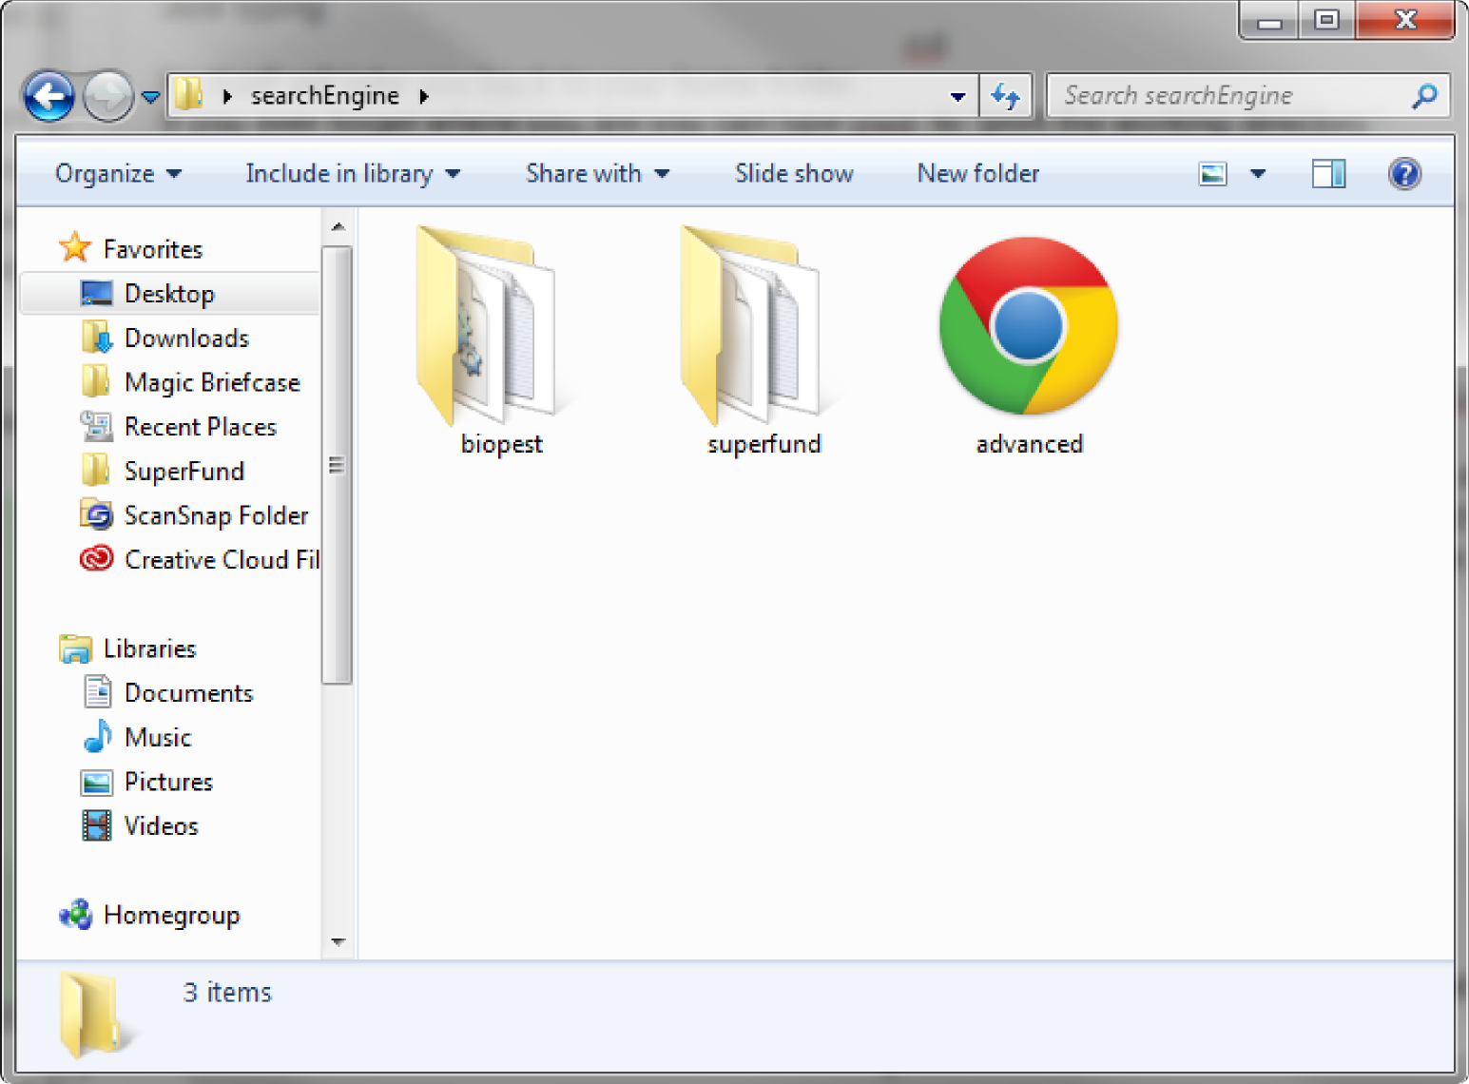

CREATING/EDITING YOUR DATABASE

To manage our publications, we use a program called Citavi. “Citavi is a reference management program for Microsoft Windows published by Swiss Academic Software in Wädenswil, Switzerland” (Wikipedia “Citavi”). It formats your references for you, and creates what are called “Citation keys”. If you use Citavi and want to edit how the Citation keys are formatted, simply open Tools → Options... Crtl+Oemcomma. This opens a window; under General, make sure Citation key support is checked, and click on Customize... Under this option you can format your citation keys however you want.

Citavi allows you to export all/selections of your database into a table or spreadsheet. From there, simply export it further into an Excel spreadsheet. You can also create your database anyway you like, and since we'll eventually be porting it into a SQLite3 database, if you know what you are doing, you can skip the Excel step all together. If you already have a SQLite3 database that you want to upload, then skip ahead.

If you go into the project folder you want to edit (using Windows Explorer), you can see all of the files for the project. For both superfund and biopest, I have included both the Excel spreadsheet and its .csv file. The columns I have in sfpub.xlsx are:
title, author, keywords, abstract, project_core, number, page_range, year, volume, periodical, citation, and link.
The columns in biopestpubs.xlsx are:
bibnum, title, author, year, periodical, volume, nuumber, page_range, parent_title, citation, keyword, project, and link.

If you don't know database management, you can simply add your new rows to the Excel spreadsheet, and then move onto the next section.

Converting your Database to SQL

Now we want to convert our updated Excel spreadsheet to a SQLite3 database.
Save a copy of the spreadsheet as a .csv file. When you do this step, your program should open a window asking you what field and text delimiters you want to use. It is hugely important that you tell it that you want a bar ( or | ) as your field delimiter. I use LibreOffice, and this is what my window looks like just before I click 'Okay'.
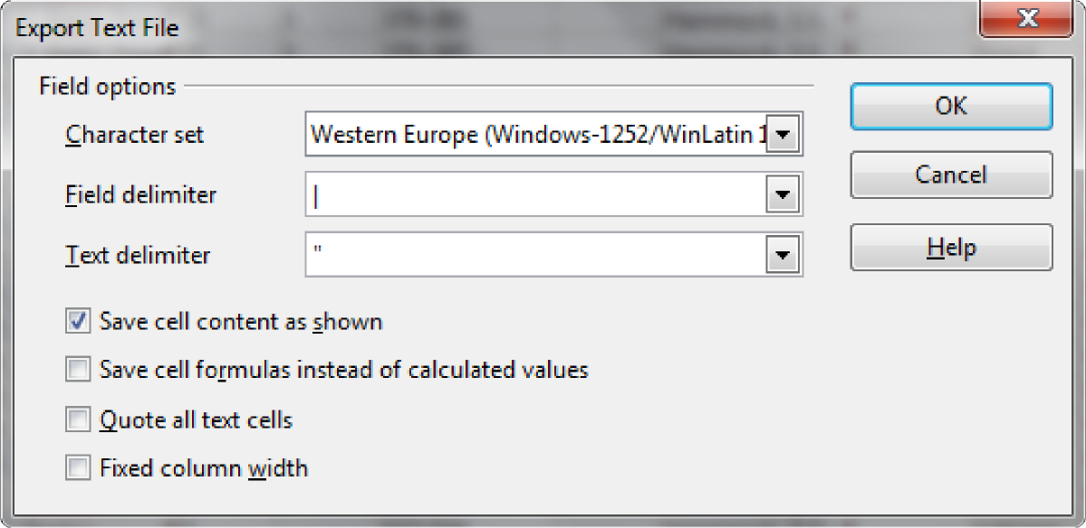

I am planning on writing a script to convert a csv to a SQLite3 database and upload everything to Heroku for you (for simple database edits), so you don't have to take these steps to change the database. However, until I start/finish that, I just use this online tool. This is what it looks like.
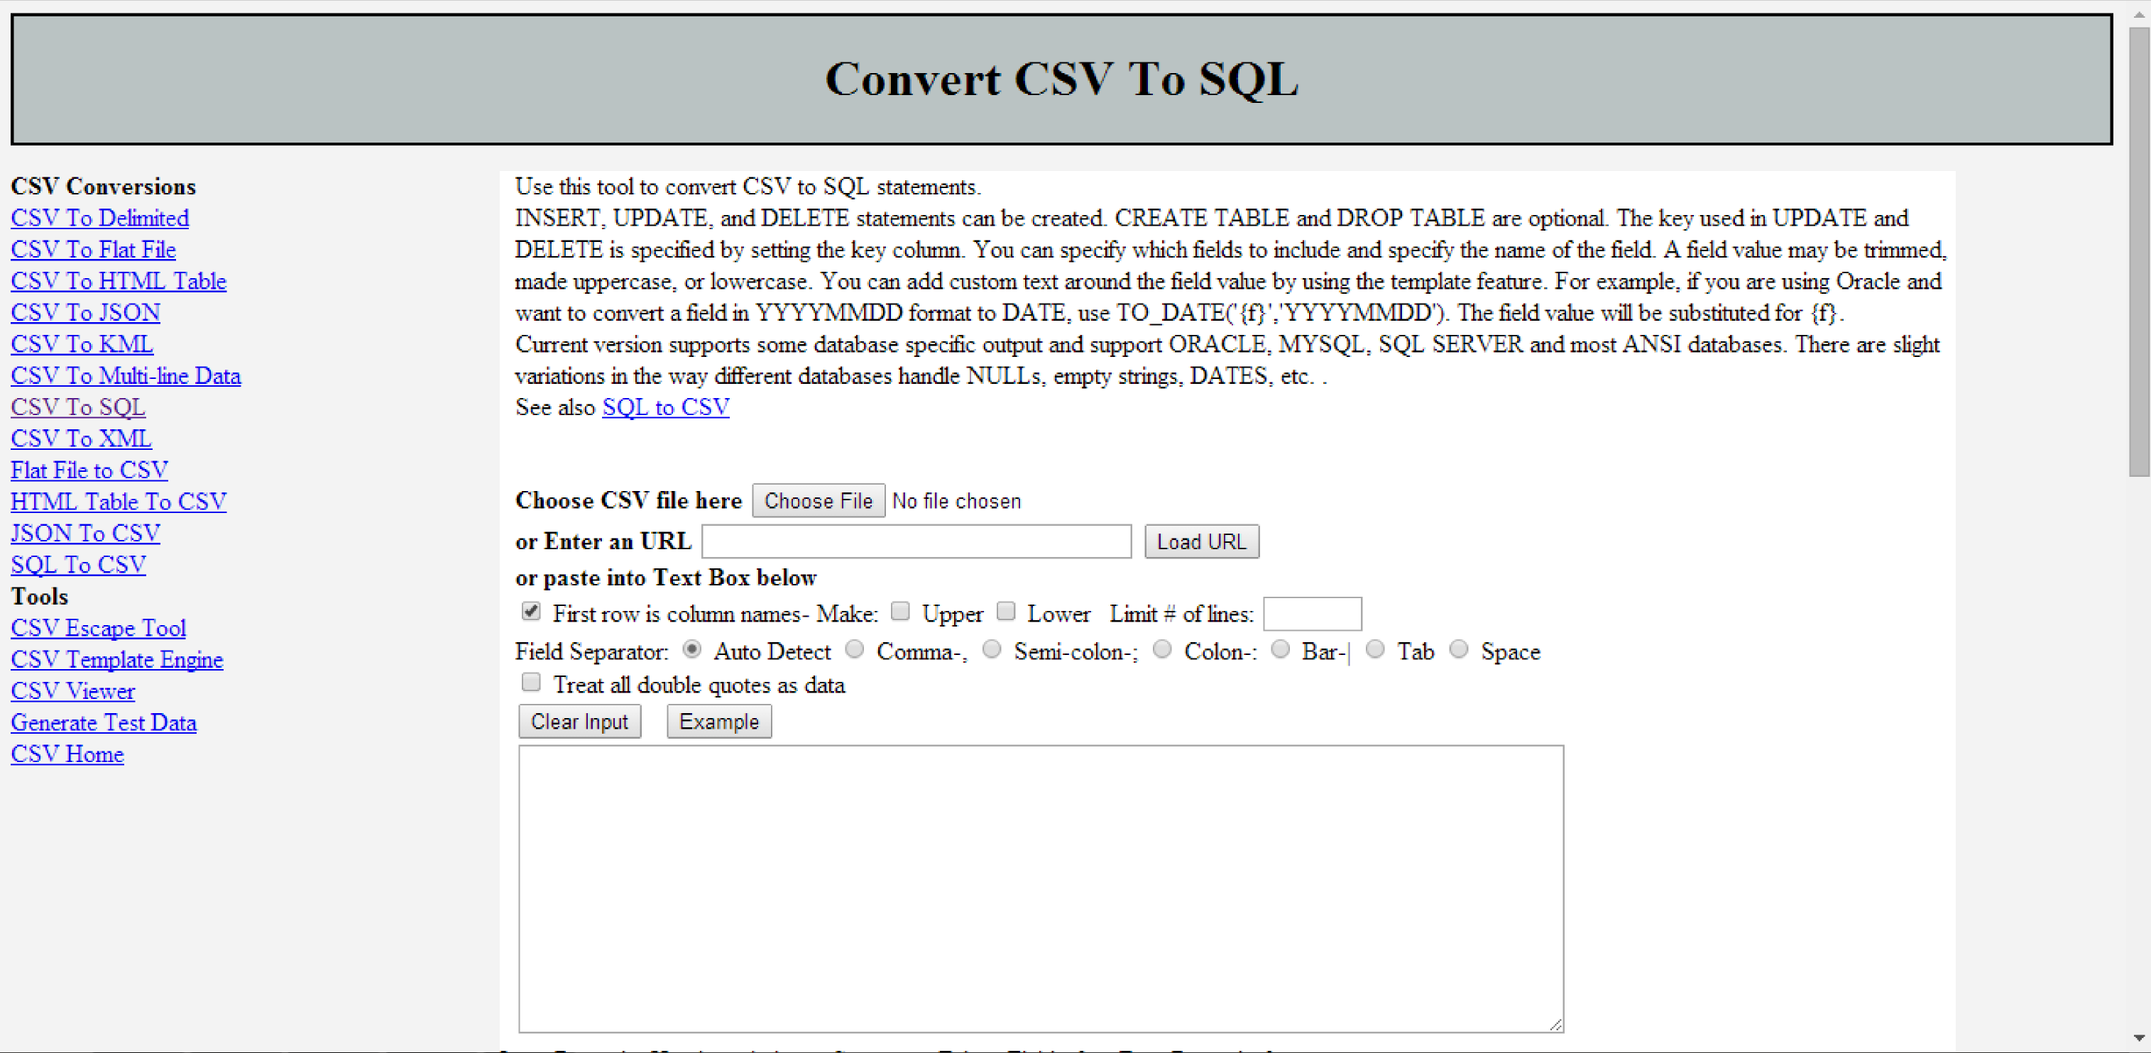

Where it says Choose CSV files here, upload the .csv file of the edited database. For the rest of the options, I always have my top row of Excel spreadsheets the column names, if you don’t, make sure you uncheck that box. Again, for the field separator, it is hugely important to choose Bar-|, because otherwise the database we are building won't resemble our Excel file.
You can ignore the Sort CSV box.

Rename the Table Name to biopest or superfund (depending on which you are editing). It is important to not forget to name it properly, or else the code won't be able to find it.

Make sure Create Table is checked, and IF NOT EXISTS right next to it. Likewise, make sure Drop Table and IF EXISTS are both checked.

Leave Enclose field names below unchecked, as well as the following two fields.

When you get to the table, uncheck any boxes that are checked for Key or Required.

Change the convertcsv.sql name to superfund.sql or hammock.sql (again, depending on which one you are editing), then scoll back up the page and hit Convert CSV to SQL Insert, to recreate the code in the bottom box.

Right before I click Convert CSV to SQL Insert, my window looks like this:
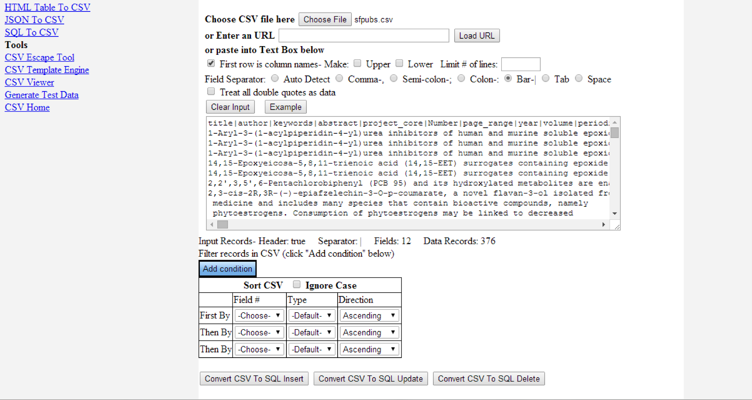
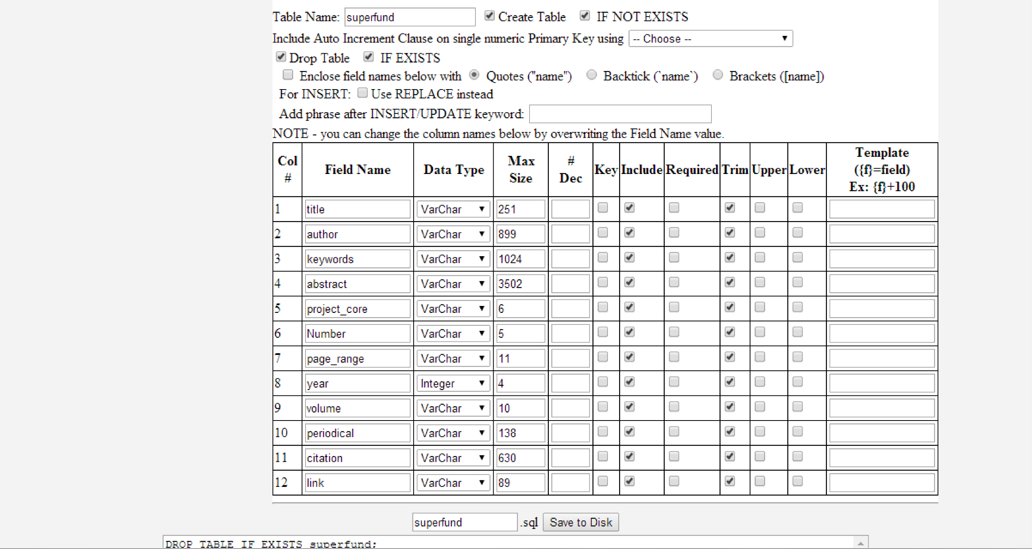

Now you can either click on Save to Disk, or copy and paste the whole thing out. Either way, we want it to replace the SQL file in the project folder. So I save superfund.sql back into the folder searchEngine\superfund (Unix shows file paths with forward slashes /; Windows uses backslashes \).

Now we want to execute the code to rebuild the edited databases. If you've closed Git Bash, open it back up and cd into the directory where you've stored the project files. So I execute
cd Desktop/searchEngine/superfund
and since I have the updated superfund.sql file here, all I have to run to rebuild the database is

Type the words
git init
to create an empty git repository. This allows you to talk to the remote git repository that is storing my code. You should get back
Initialized empty Git repository in c:/Users/path/to/directory/

You can type the command
git remote -v
to see that you aren't currently connected to any remote repository. Now type
git remote add https://github.com/veggielover77/searchEngine.git
to add the repository that you'll be copying. You can retype git remote -v to ensure that you connected properly. You should get
origin https://github.com/veggielover77/searchEngine.git (fetch)
origin https://github.com/veggielover77/searchEngine.git (push)
in return.

If you accidentally typed the wrong address, type
git remote rm origin
git remote add https://github.com/veggielover77/searchEngine.git

We will be “fetching” the remote repository to our local directory. When we are done updating the database, we will then “push” the changes to Heroku, the hosting website for our search engine web app. To grab the files, type

